IT2120 – Probability & Statistics

IT24103687

Weerasinghe N.A.W.R.N.W.

Labsheet 03

**Exercise**

Question 1

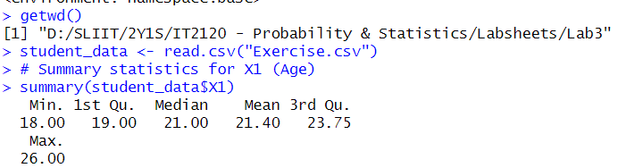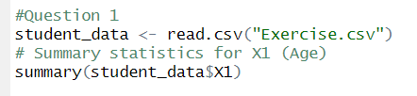

Question 2

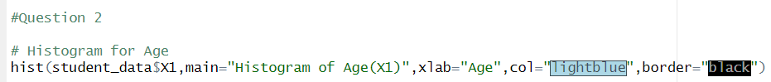

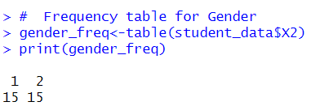

Question 3

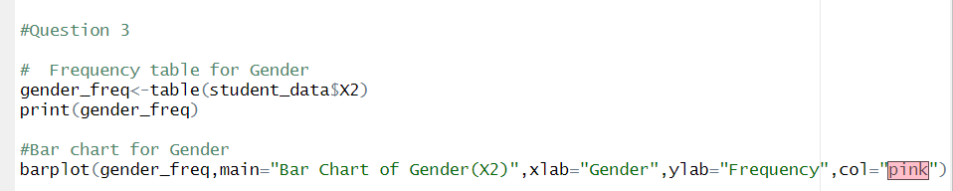

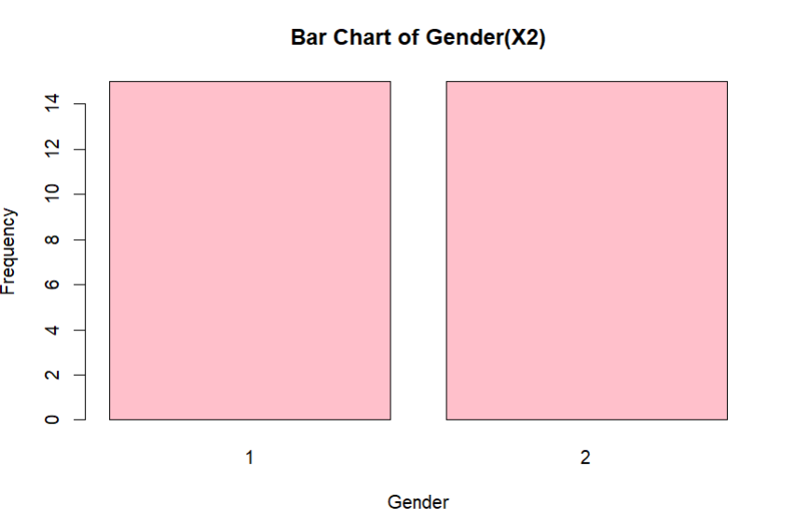

Question 4

